AI ASSISTANT CODING

NAME : G.Vamshi
ROLL NO : 2303A51448
BATCH NO : 21

Task 1: Cleaning Sensor Data
❖ Scenario:
❖ You are cleaning IoT sensor data where negative values are invalid.
❖ Task:
Use Gemini in Colab to generate a function that filters out all negative
numbers from a list.
❖ Expected Output:
➢ Before/after list
➢ Screenshot of Colab execution

OUTPUT:

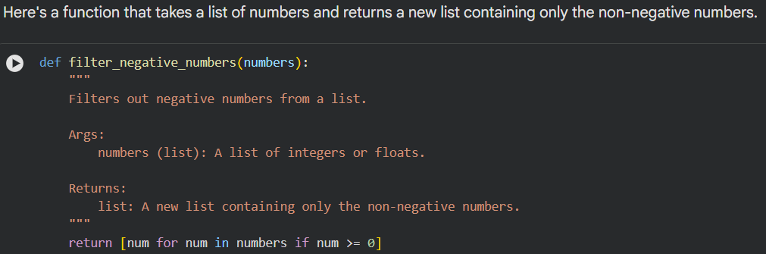

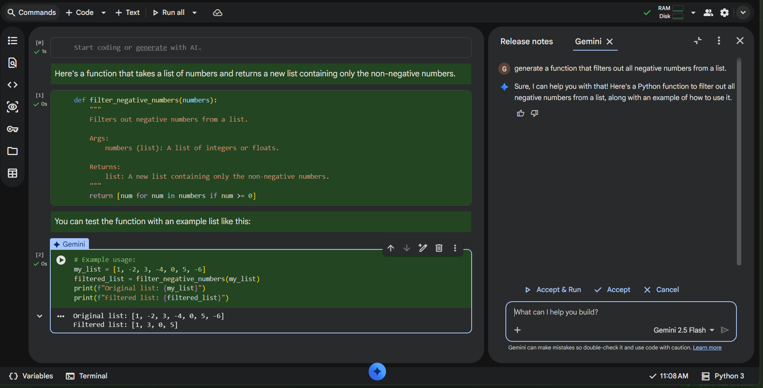

Task 2: String Character Analysis
❖ Scenario:
You are building a text-analysis feature.
❖ Task:
Use Gemini to generate a Python function that counts vowels, consonants,
and digits in a string.
❖ Expected Output:
➢ Working function
➢ Sample inputs and outputs

OUTPUT:

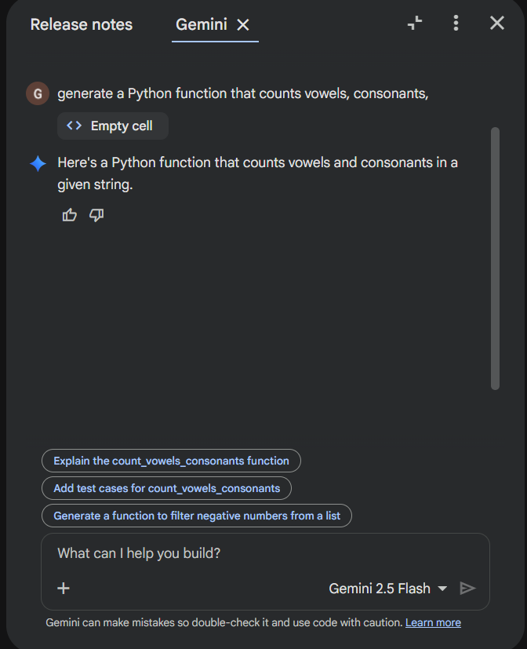

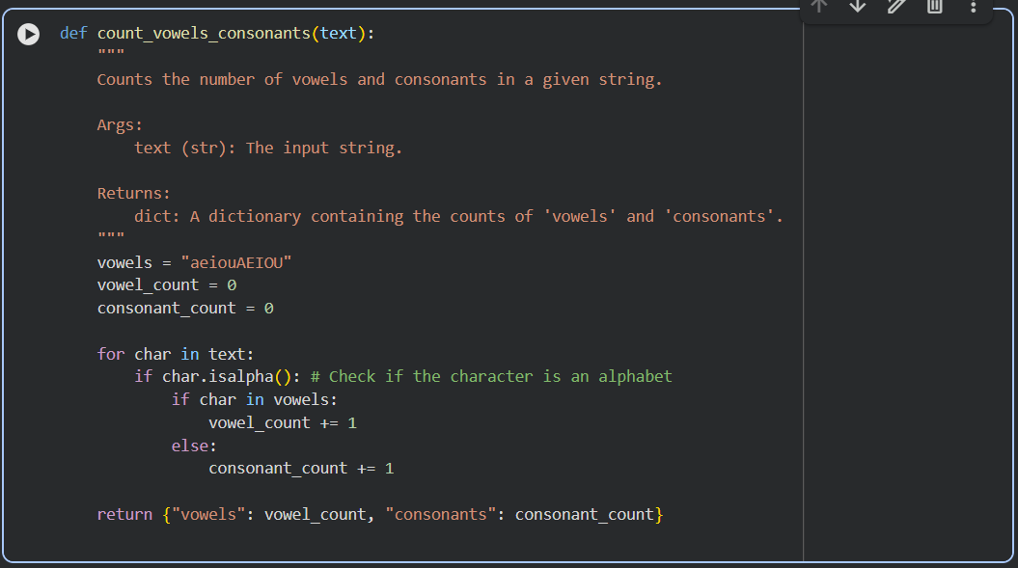

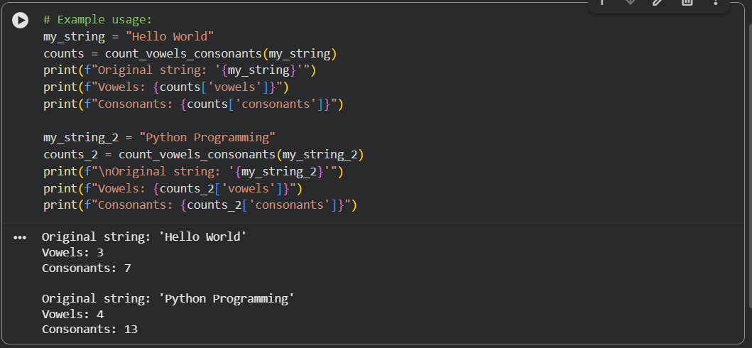

Task 3: Palindrome Check – Tool Comparison
❖ Scenario:
You must decide which AI tool is clearer for string logic.
❖ Task:
Generate a palindrome-checking function using Gemini and Copilot, then
compare the results.
❖ Expected Output:
➢ Side-by-side code comparison
➢ Observations on clarity and structure

Output :

CODE GENERATED BY GEMINI:
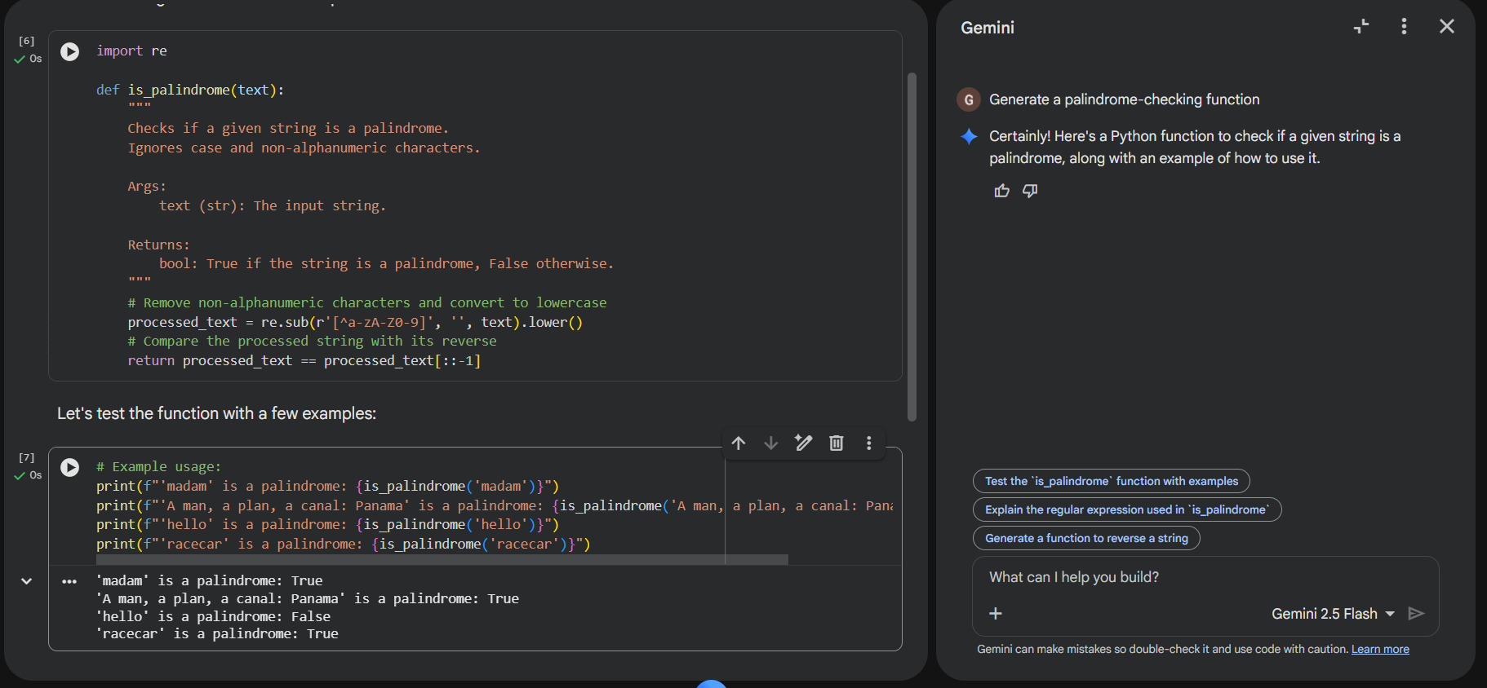

CODE GENERATED BY COPILOT :
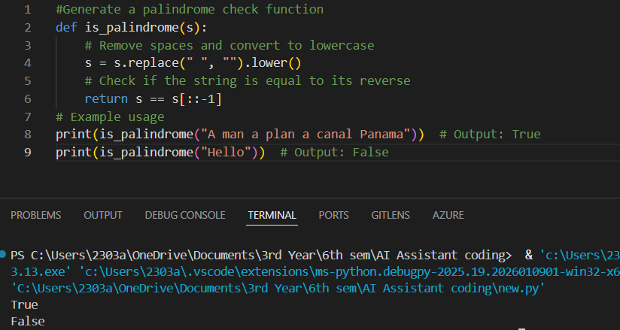

Observations on Clarity
Gemini Code:
Clear, well-documented, and professionally structured with reusable functions. It handles edge cases effectively by ignoring case and non-alphanumeric characters, making it more robust and production-ready.
Copilot Code:
Simple, concise, and beginner-friendly. Easy to follow but limited in scope, with minimal output and basic preprocessing.
Summary:
Gemini is comprehensive and polished, while Copilot is lightweight and ideal for quick learning or testing.

Task 4: Code Explanation Using AI
❖ Scenario:
You are reviewing unfamiliar code written by another developer.
❖ Task:
Ask Gemini to explain a Python function (prime check OR palindrome
check) line by line.
❖ Expected Output:
➢ Code snippet
➢ AI explanation
➢ Student comments on understanding

OUTPUT :

AI Explanation :

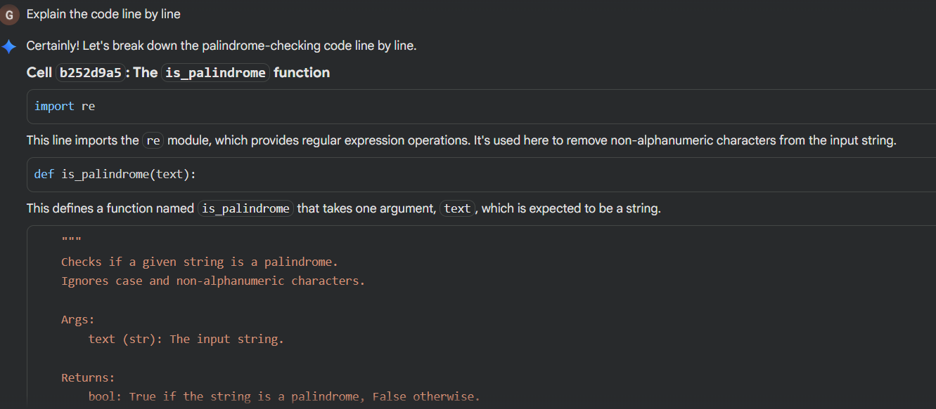

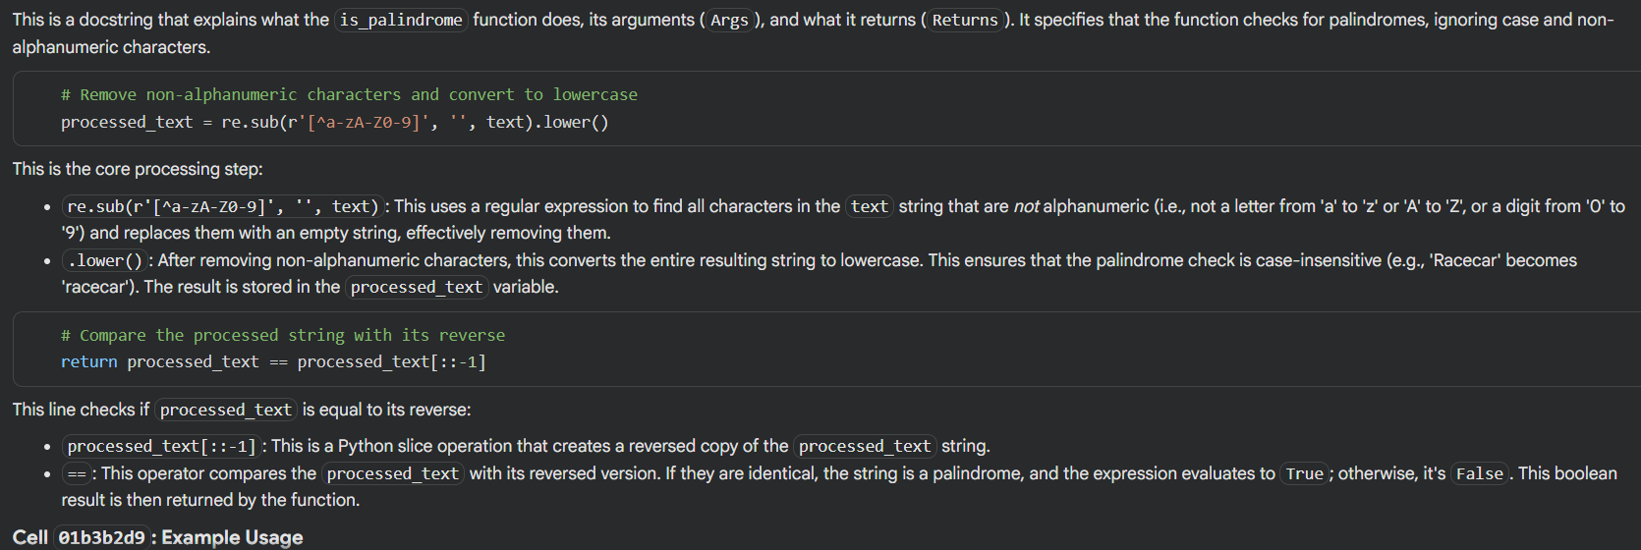

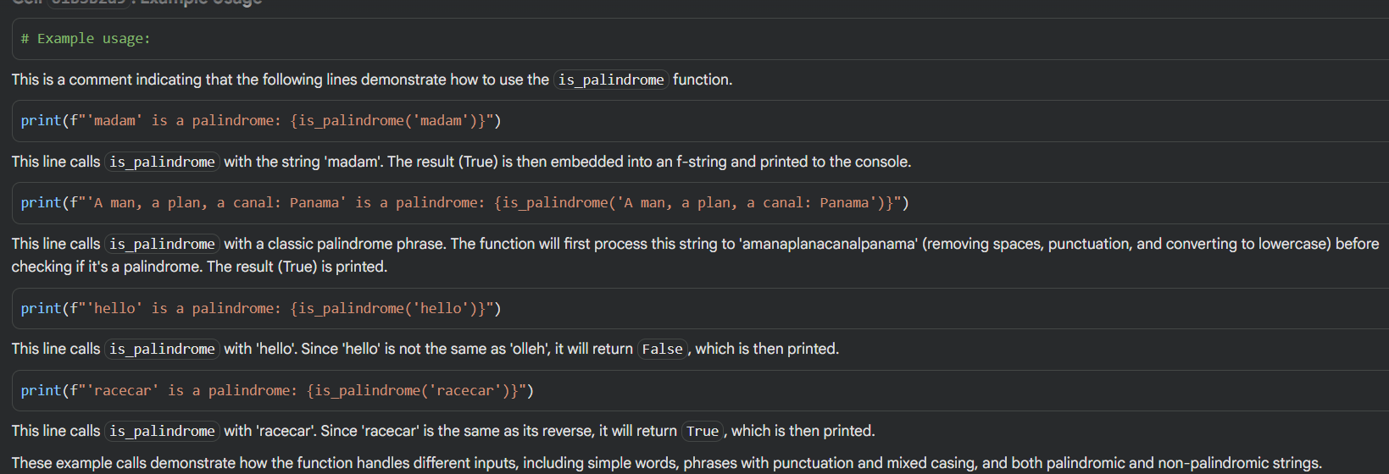

Clear Understanding:

- “The explanation was very clear. I now understand how regular expressions are used to clean the string.”
- “I get why .lower() is important — it makes the check case-insensitive.”
- “The slicing trick [::-1] for reversing a string is neat, I hadn’t seen that before.”
- “The examples helped me see how the function works with both simple words and complex phrases.”

